

Cardiac Rehab/Well Fit

Address: 1600 Joseph Drive, Bryan (across from Blinn College).
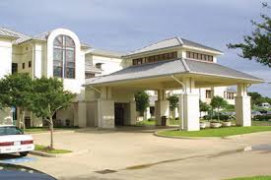
Sign-In: Cardiac Rehab Gym
Directions to sign-in binder - enter through circle drive way. Walk through the lobby and turn right (across from elevators). Walk straight down this hallway and follow the curve to the left. Continue down this hall until you see the Cardiac Rehab sign to your left, directly past the restrooms. Walk through the PT area and you will enter the Cardiac gym. The binder is on the book shelf just under the white board. Please be sure to sign in and out, and these will be sent to Volunteer Services at the end of each month.

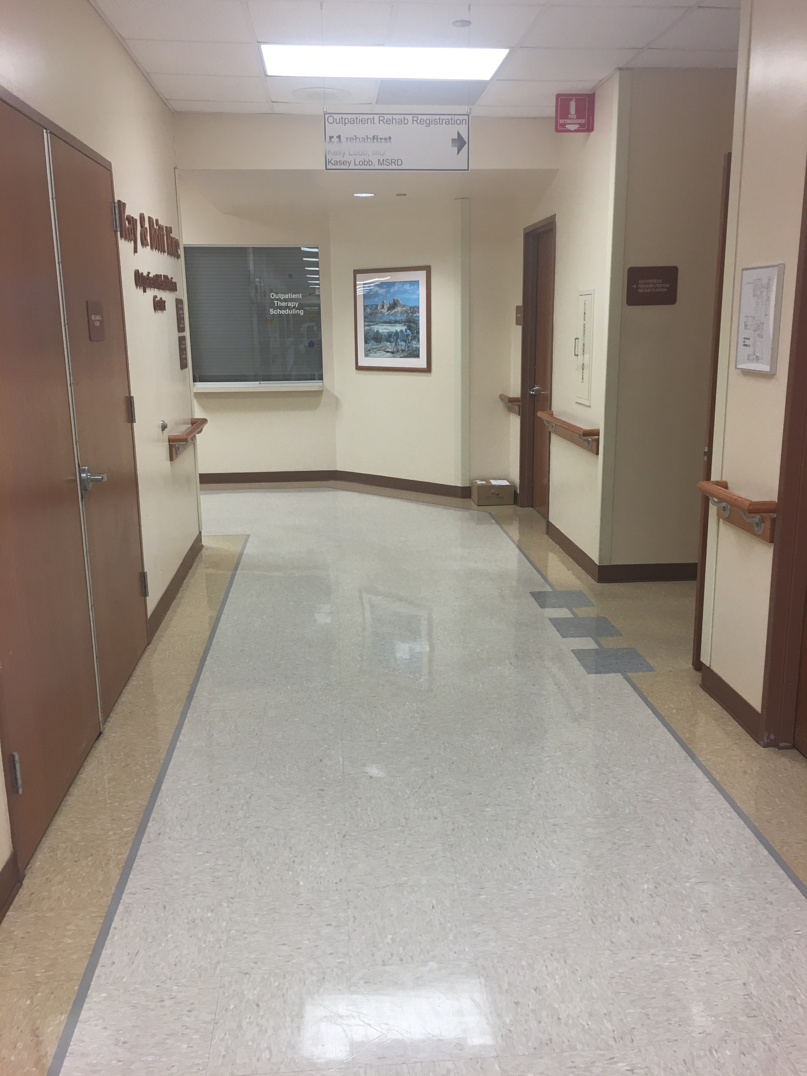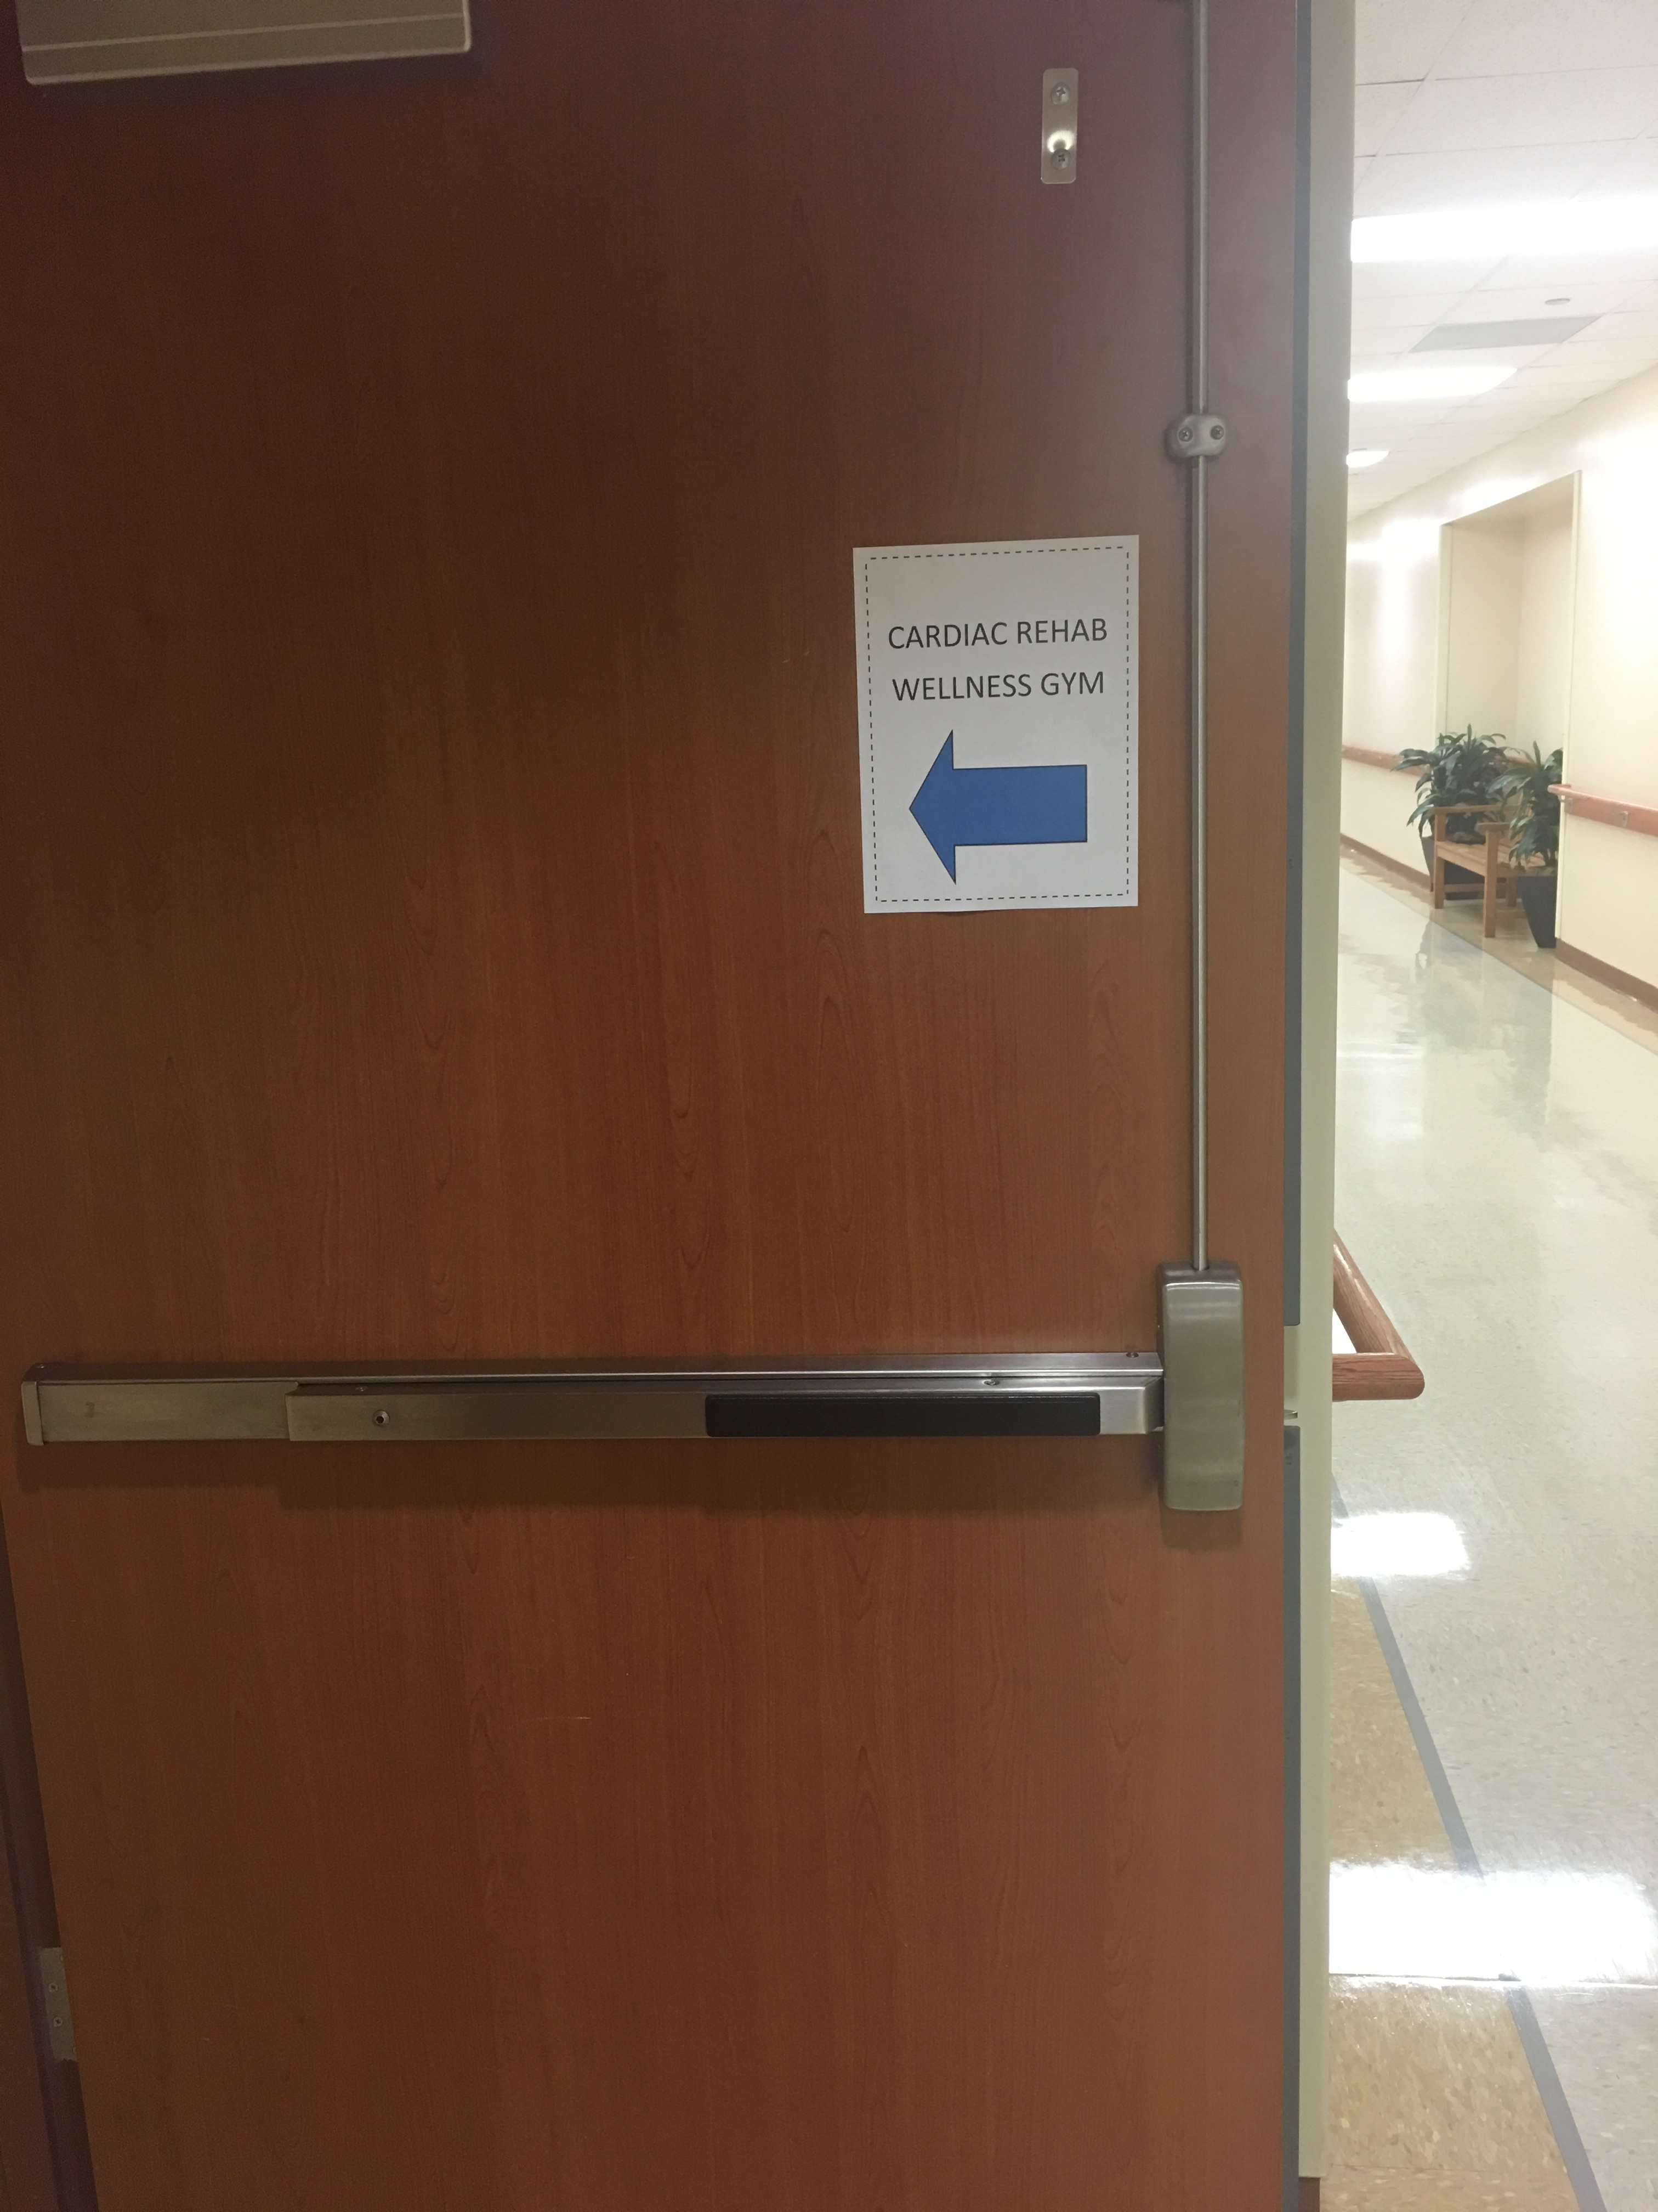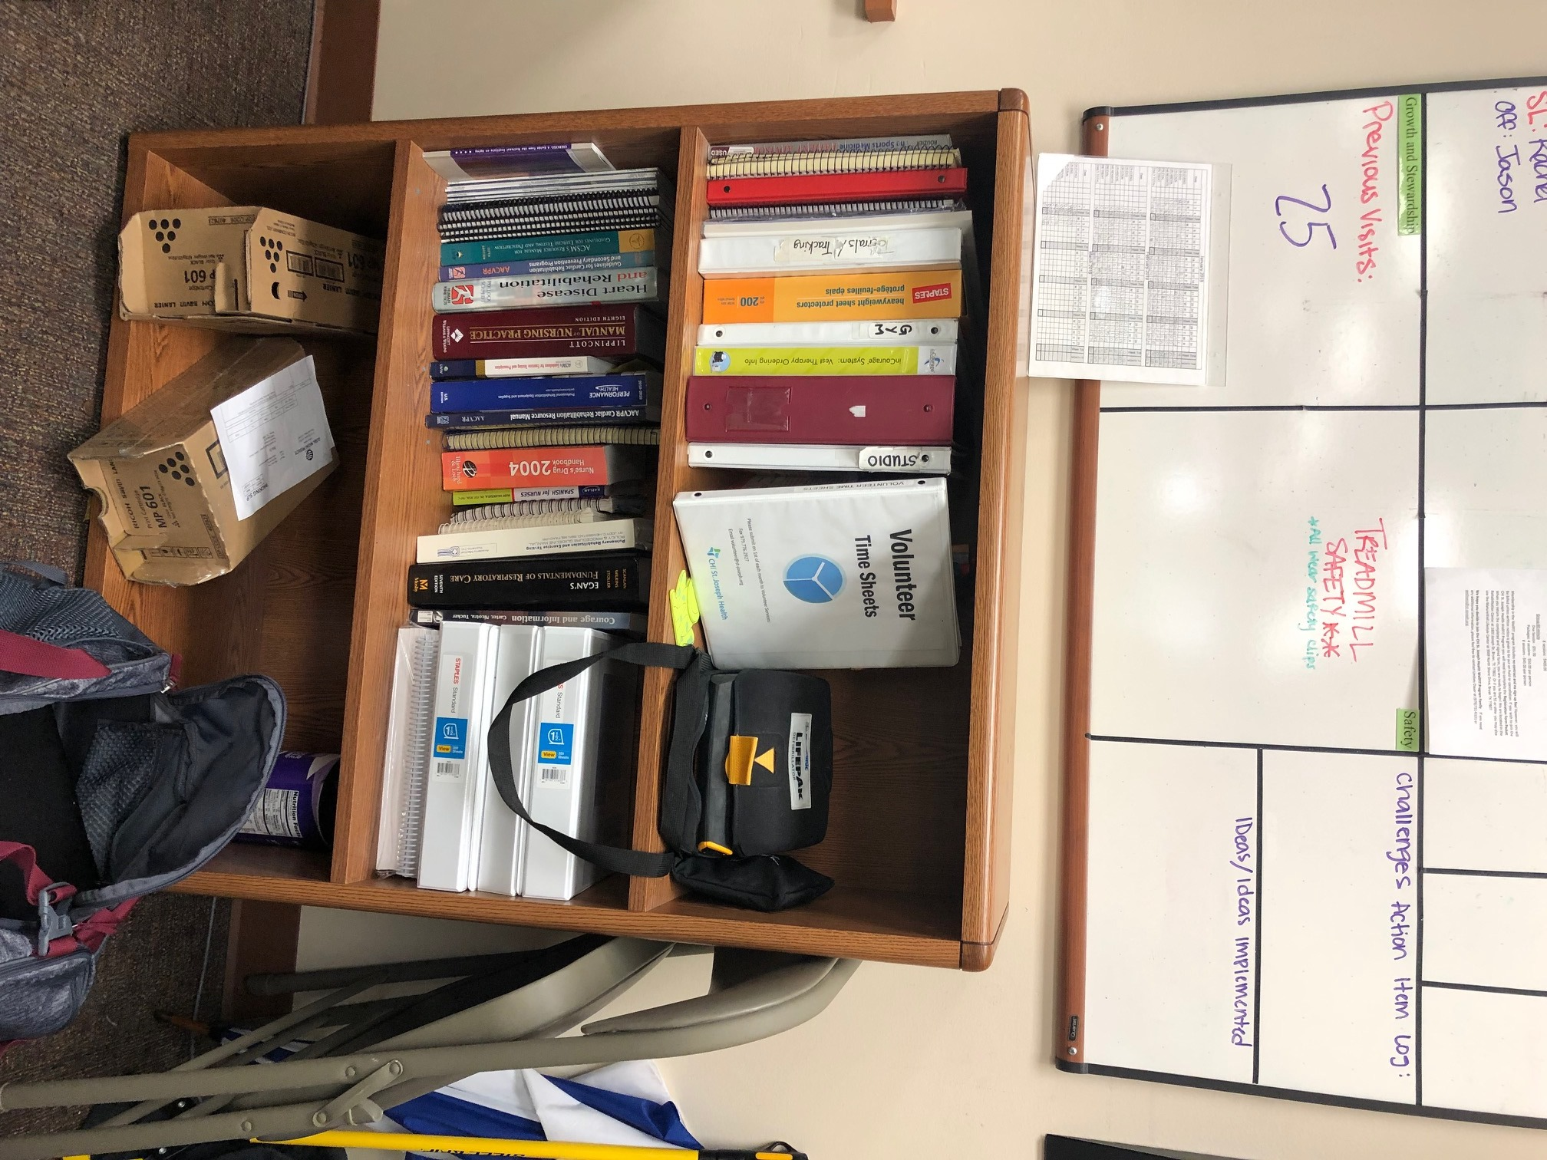
Curve Left

Department Contact Information:
Report to: Leslie Martinek
Phone: 979.821.7578

Department Orientation Checklist: Will be completed during your first schedule shift

Additional Orientation Courses: Not required

- If you are ill or cannot make your shift, please call the number listed above to report your absence. You do not need to call Volunteer Services.
- Dress Code: Assigned Uniform Top, khaki pants, and rubber soled shoes. No denim, capris, shorts, or sleeveless shirts. No perfume or cologne in patient areas.
- Remember to take your department orientation checklist (included in this packet) on your first day or to scheduled department orientation. Please complete and return to Volunteer Services.
New Volunteers:
- Your identification badge will be delivered to your location for you to pick up on your first day. You are required to wear your badge while on duty. If you forget your badge you will be asked to leave.
How to turn in Paperwork to Volunteer Services:
- Interoffice mail to Volunteer Services, drop off at the Auxiliary office, scan and email to volunteer@st-joseph.org, or fax to 979.776.5330.

Cardiac Rehab/Well Fit

Objective: A physician referred program in a closely monitored rehab setting working with cardiac and pulmonary patients. Most patients will have continuous EKG monitoring during each exercise session. Work with an exercise physiologist.

Hours: Monday & Wednesday 6 am – 12 pm & 1:00 – 4:00 pm; Tuesday & Thursday 7am – 6:00 pm; Friday 6 am – 12 pm

Qualifications:
- Demonstrates ability to communicate and listen well.
- Mature, positive, service-oriented individual.
- Ability to work closely with other members of the team.
- Physical ability to withstand sitting, standing, reaching and lifting.

Training:
- Completion of SJRHC Orientation.
- Completion of Department Orientation.
- Patient vitals (if applicable)

Competencies:
- Understand and follow directions.
- Work effectively with others.
- Recognize and respect multi-cultural needs of our patients and guests.
- Work with confidential information.

Responsibilities:
- Notify department of any absences; sign in and out when reporting to and leaving volunteer assignment, wear volunteer uniform and SJRHC-issued identification badge; maintain confidentiality at all times and do not discuss any information learned while on-site to anyone outside of the unit, department, or SJRHC.
- Wheel patients to and from therapy areas (follow “Wheelchair Procedures”)
- Observe patient therapy and assist therapists as requested.
- Administrative tasks such as filing, putting together patient education packets, and so forth.
- Taking patient vitals, and helping with cardiac monitors
- Clean gym equipment

Department Orientation Checklist

Cardiac Rehab

VOLUNTEER NAME: _____________________________________

_____Introduction to team members

_____Department tour

_____Show where to sign in and out to record volunteer hours (if needed)

_____Review basic department functions

_____Define who they report to when on duty

_____Define who to call when the volunteer will be unable to volunteer for their assigned shift (information is not reported to Vol. Svcs.)

_____Point out location of nearest fire alarm and extinguishers

_____Review department evacuation procedure

_____Review volunteer duties in your department

_____Review wheelchair procedures (if applicable)

___________________________ ____________________________ _________
Department Team Member Signature Volunteer Signature Date

PLEASE RETURN FORM TO Volunteer Services by dropping off at Auxiliary Room or emailing it to Volunteer@st-joseph.org

Volunteer Time Sheet
Please send time sheets twice a month to Volunteer Services: Email volunteer@st-joseph.org.

Assignment: Cardiac Rehab

Date | Name | Time In | Time Out | Total Hours

Please send time sheets twice a month to Volunteer Services: Email volunteer@st-joseph.org.

Volunteer Expectations and Duties

Cardiac Rehab

- Maintain professionalism when speaking to patients and staff
- Visit with Patients – Introduce yourself as a volunteer, ask if the patient needs anything
- Mingle with the patients while they exercise. Make eye contact and smile!!! ☺

- Assist patients with adjusting seat height/length and entering setting on the equipment
- Verify that the patients are exercising at the correct settings
- Operational Duties
- Turn off and clean the heart monitors after the patient has been discharged
- File daily reports in patient charts
- Wipe down equipment in gym (including free weights)
- Make evaluation folders and copies of education material (when needed)
- Refill water jug (stored in electrical room/ use blue electrical key)
- Stock equipment (electrodes, towels, gloves, Kleenex, sani wipes)
- Be prepared to obtain blood pressures and oxygen percentage as the patients enter and exit the gym and communicate those readings to the staff member at the monitor desk
- Stay on the exercise floor throughout the exercise session
- Monitor patients for safety. Do not sit on the equipment unless showing how to use it.

