

Sports Therapy

Address: 2803 Earl Rudder Fwy South, Suite 102
College Station, TX
on the feeder road between FM 2818 (Emerald Parkway) & Southwest Parkway. Traveling south on Highway 6, exit Emerald Parkway, u-turn under overpass, stay on feeder, professional building is located on right 0.6 miles

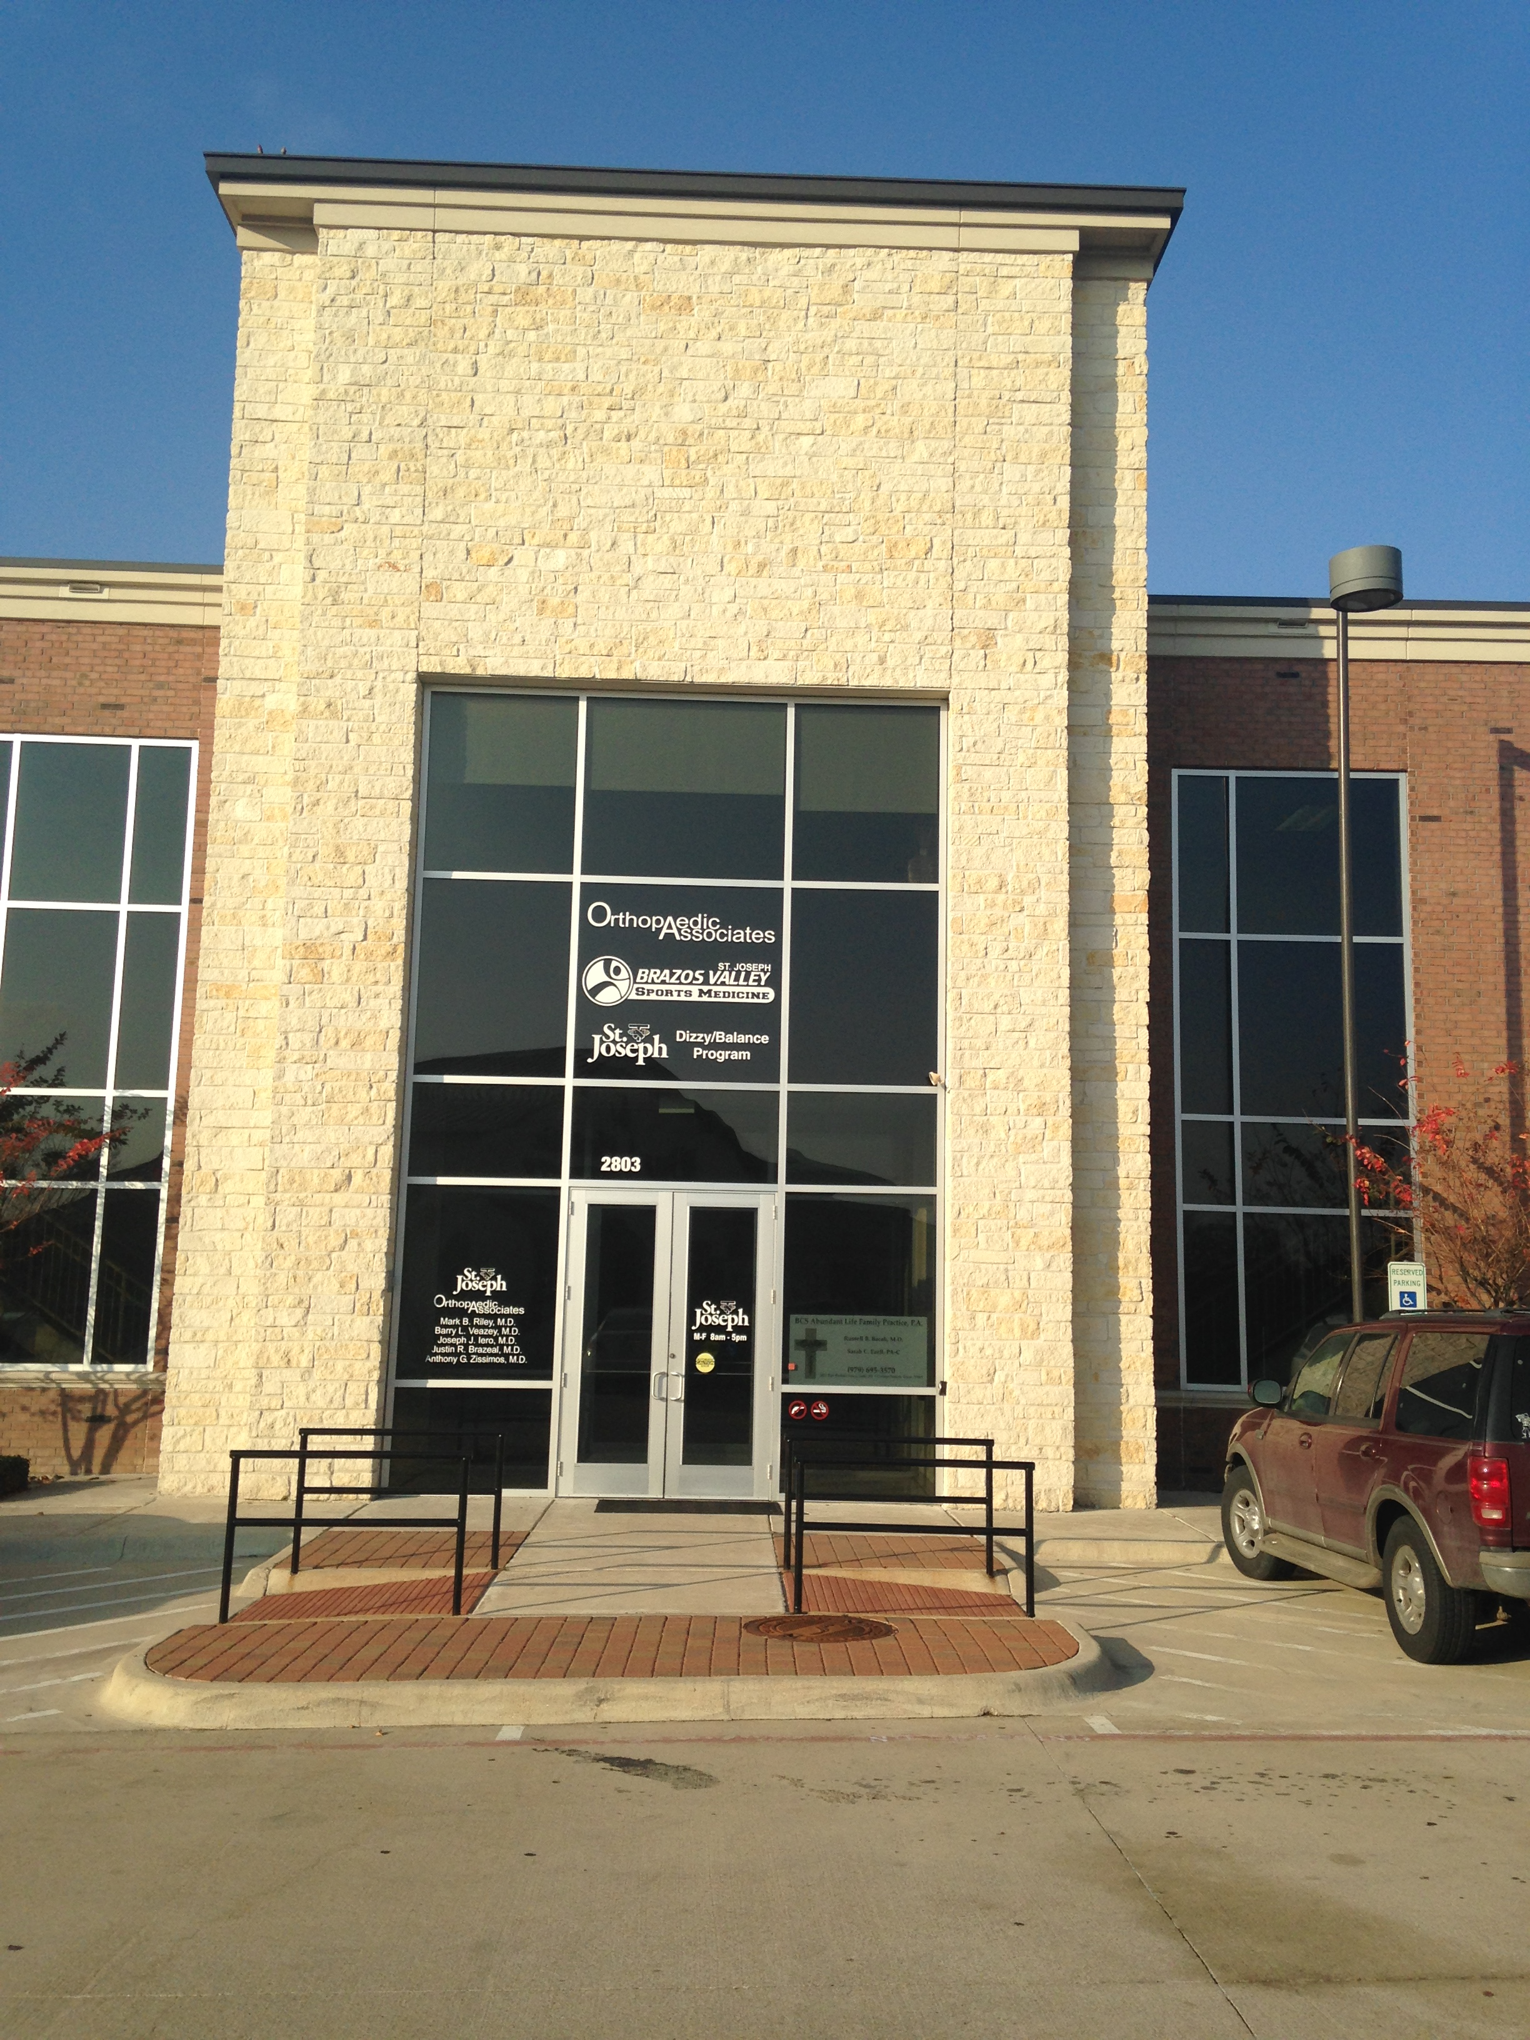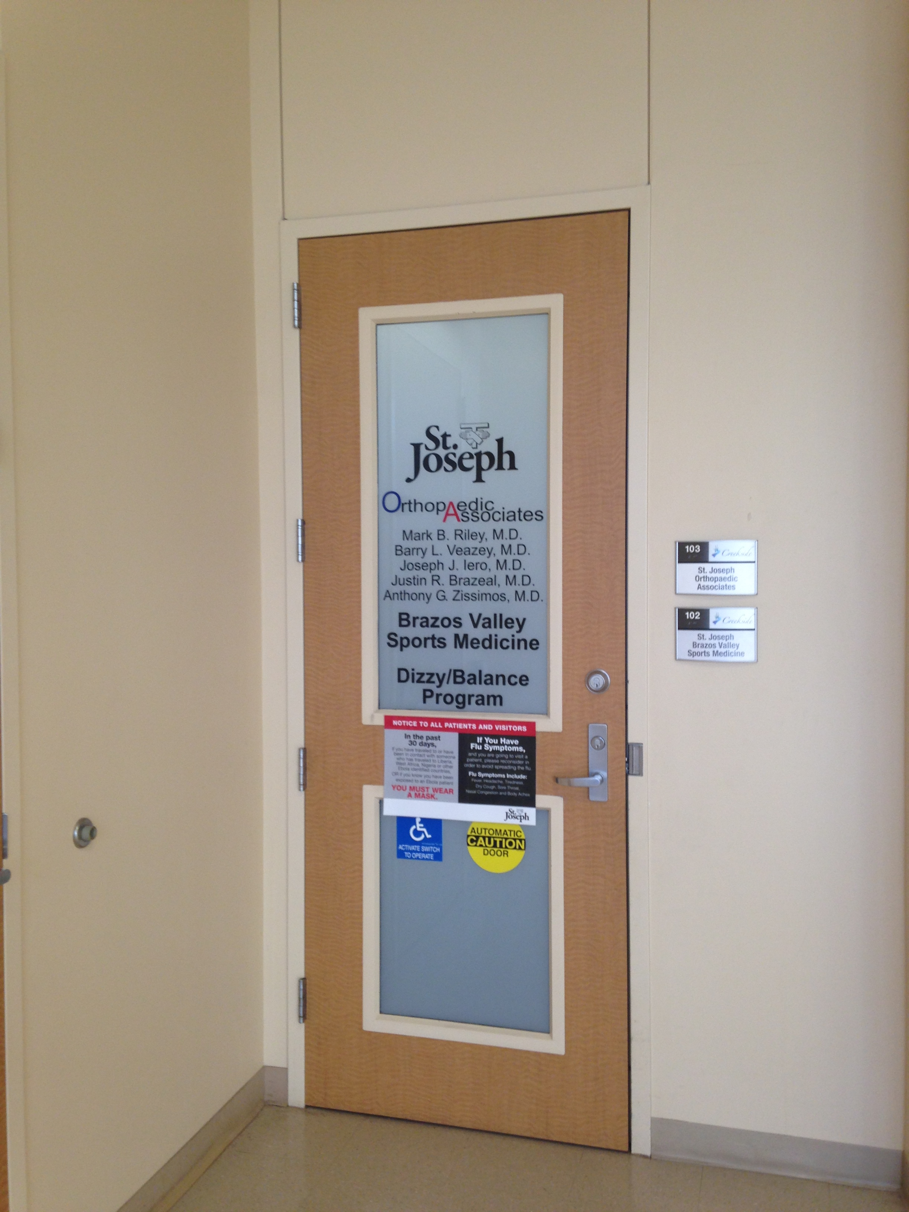
Exterior Entrance
Interior Entrance to BVSM

Department Contact Information:

Report to: Matt Martin
Phone: 979.731-5274
Sign-in: Volunteer Binder at BVSM
Director: Emily Jarvis
Coordinator: Matt Martin

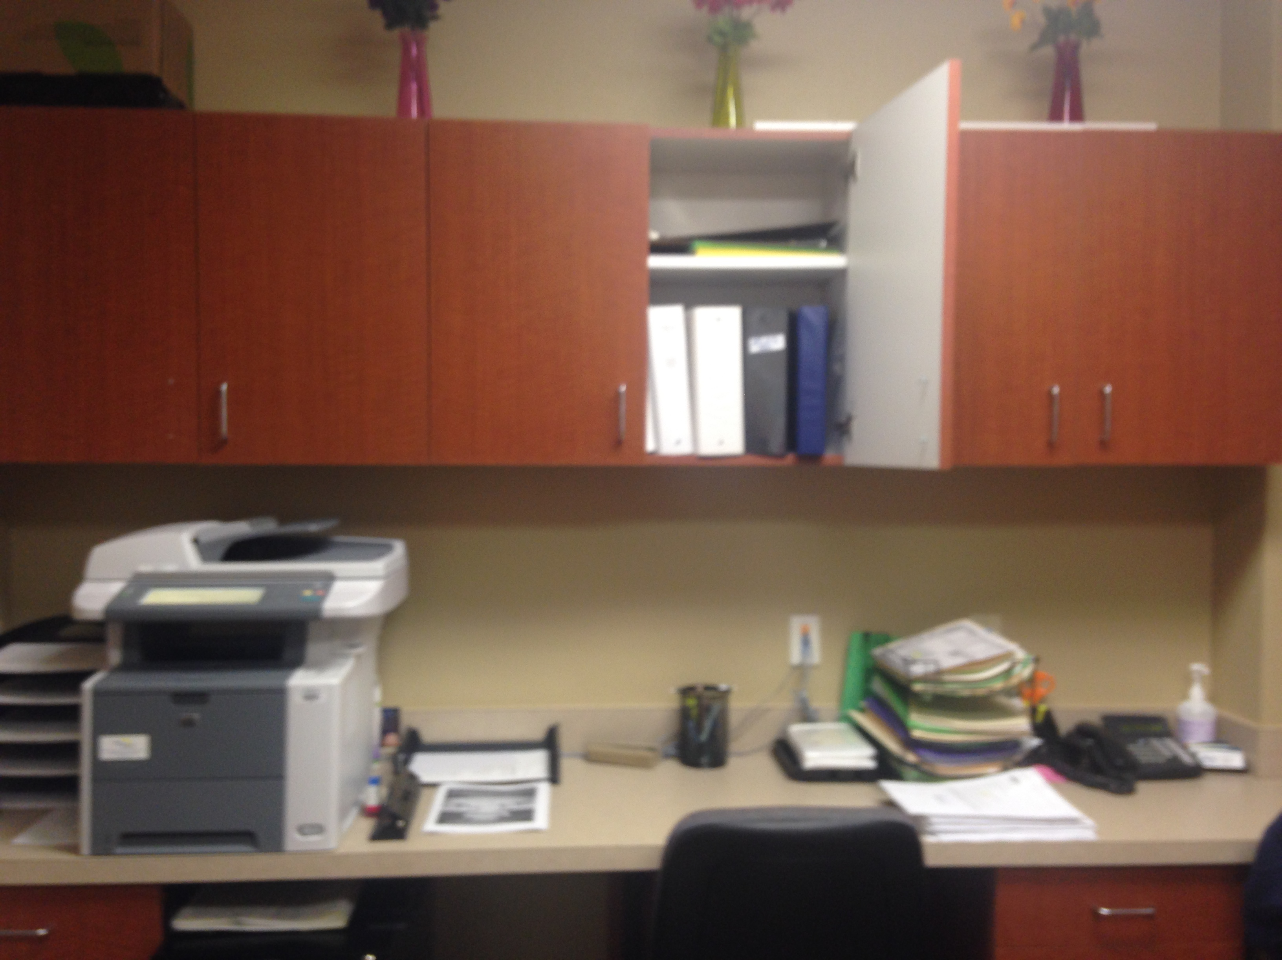
Volunteer Log Book
- If you are ill or cannot make your shift, please call the number listed above to report your absence. You do not need to call Volunteer Services.
- Dress Code: Navy or white collared polo or shirt, khaki pants, and rubber soled shoes. No denim, capris, shorts, or sleeveless shirts. No perfume or cologne in patient areas.
- Remember to take your department orientation checklist with you to your first shift in this area. Please get it filled out and returned to Volunteer Services (wall basket in Auxiliary room).
- Volunteer Services Department can provide verification of your hours. Please email volunteer@st-joseph.org to request.
- Letters of recommendation must be requested from the department or staff member you volunteer for.
- When you have completed your volunteer service, please submit by email or in writing your resignation and turn in your identification badge.

Sports Therapy

Objective: To provide assistance to physical therapists and observe patient therapy.

Hours: Monday – Thursday 7 am – 12 pm and 1 pm – 5 pm;
Friday 8 am – 12 pm and 1 pm – 4 pm.

Qualifications:
- Demonstrates ability to communicate and listen well.
- Mature, positive, service-oriented individual.
- Ability to work closely with other members of the team.
- Physical ability to withstand sitting, standing, reaching and lifting.

Training:
- Completion of Hospital Orientation.
- Completion of Department Orientation.

Competencies:
- Understand and follow directions.
- Work effectively with others.
- Recognize and respect multi-cultural needs of our patients and guests.
- Work with confidential information.

Responsibilities:
- Notify department of any absences; sign in and out when reporting to and leaving volunteer assignment, wear volunteer uniform and issued identification badge; maintain confidentiality at all times and do not discuss any information learned while on-site to anyone outside of the unit, department, or CHI.
- Inform secretary that you are on duty.
- Observe patient therapy and assist physical therapist as requested.
- Assist physical therapist in patient therapy.

Department Orientation Checklist

Sports Medicine

VOLUNTEER: ________________________________

_____Introduction to team members

_____Department tour

_____Review basic department functions

_____Define who they report to when on duty

_____Define who to call when the volunteer will be unable to volunteer for their assigned shift (information is not reported to Vol. Svcs.)

_____Point out location of: Policy and Procedure Manual
Disaster Manual or Plan
MSDS Manual
Safety Manual
Code Cards

_____Point out location of nearest fire alarm and extinguishers

_____Review department evacuation procedure

_____Review volunteer duties in your department

_____Review wheelchair procedures (if applicable)

___________________________ ____________________________ _________
Department Team Member Signature Volunteer Signature Date

PLEASE RETURN FORM TO Volunteer Services Department by interoffice mail, fax to 979.776.2927, scan and email to volunteer@st-joseph.org.

Volunteer Time Sheet
Please send time sheets at the beginning of each month to Volunteer Services: Fax 979.776.2927 or email volunteer@st-joseph.org.

Assignment: Sports Medicine

Date | Name | Time In | Time Out | Total Hours

Please send time sheets at the beginning of each month to Volunteer Services: Fax 979.776.2927 or email volunteer@st-joseph.org.

