

Senior Enrichment Assistant

Location: CHI St. Joseph Health Skilled Nursing & Rehab
2333 Manor Drive, Bryan, TX 77802
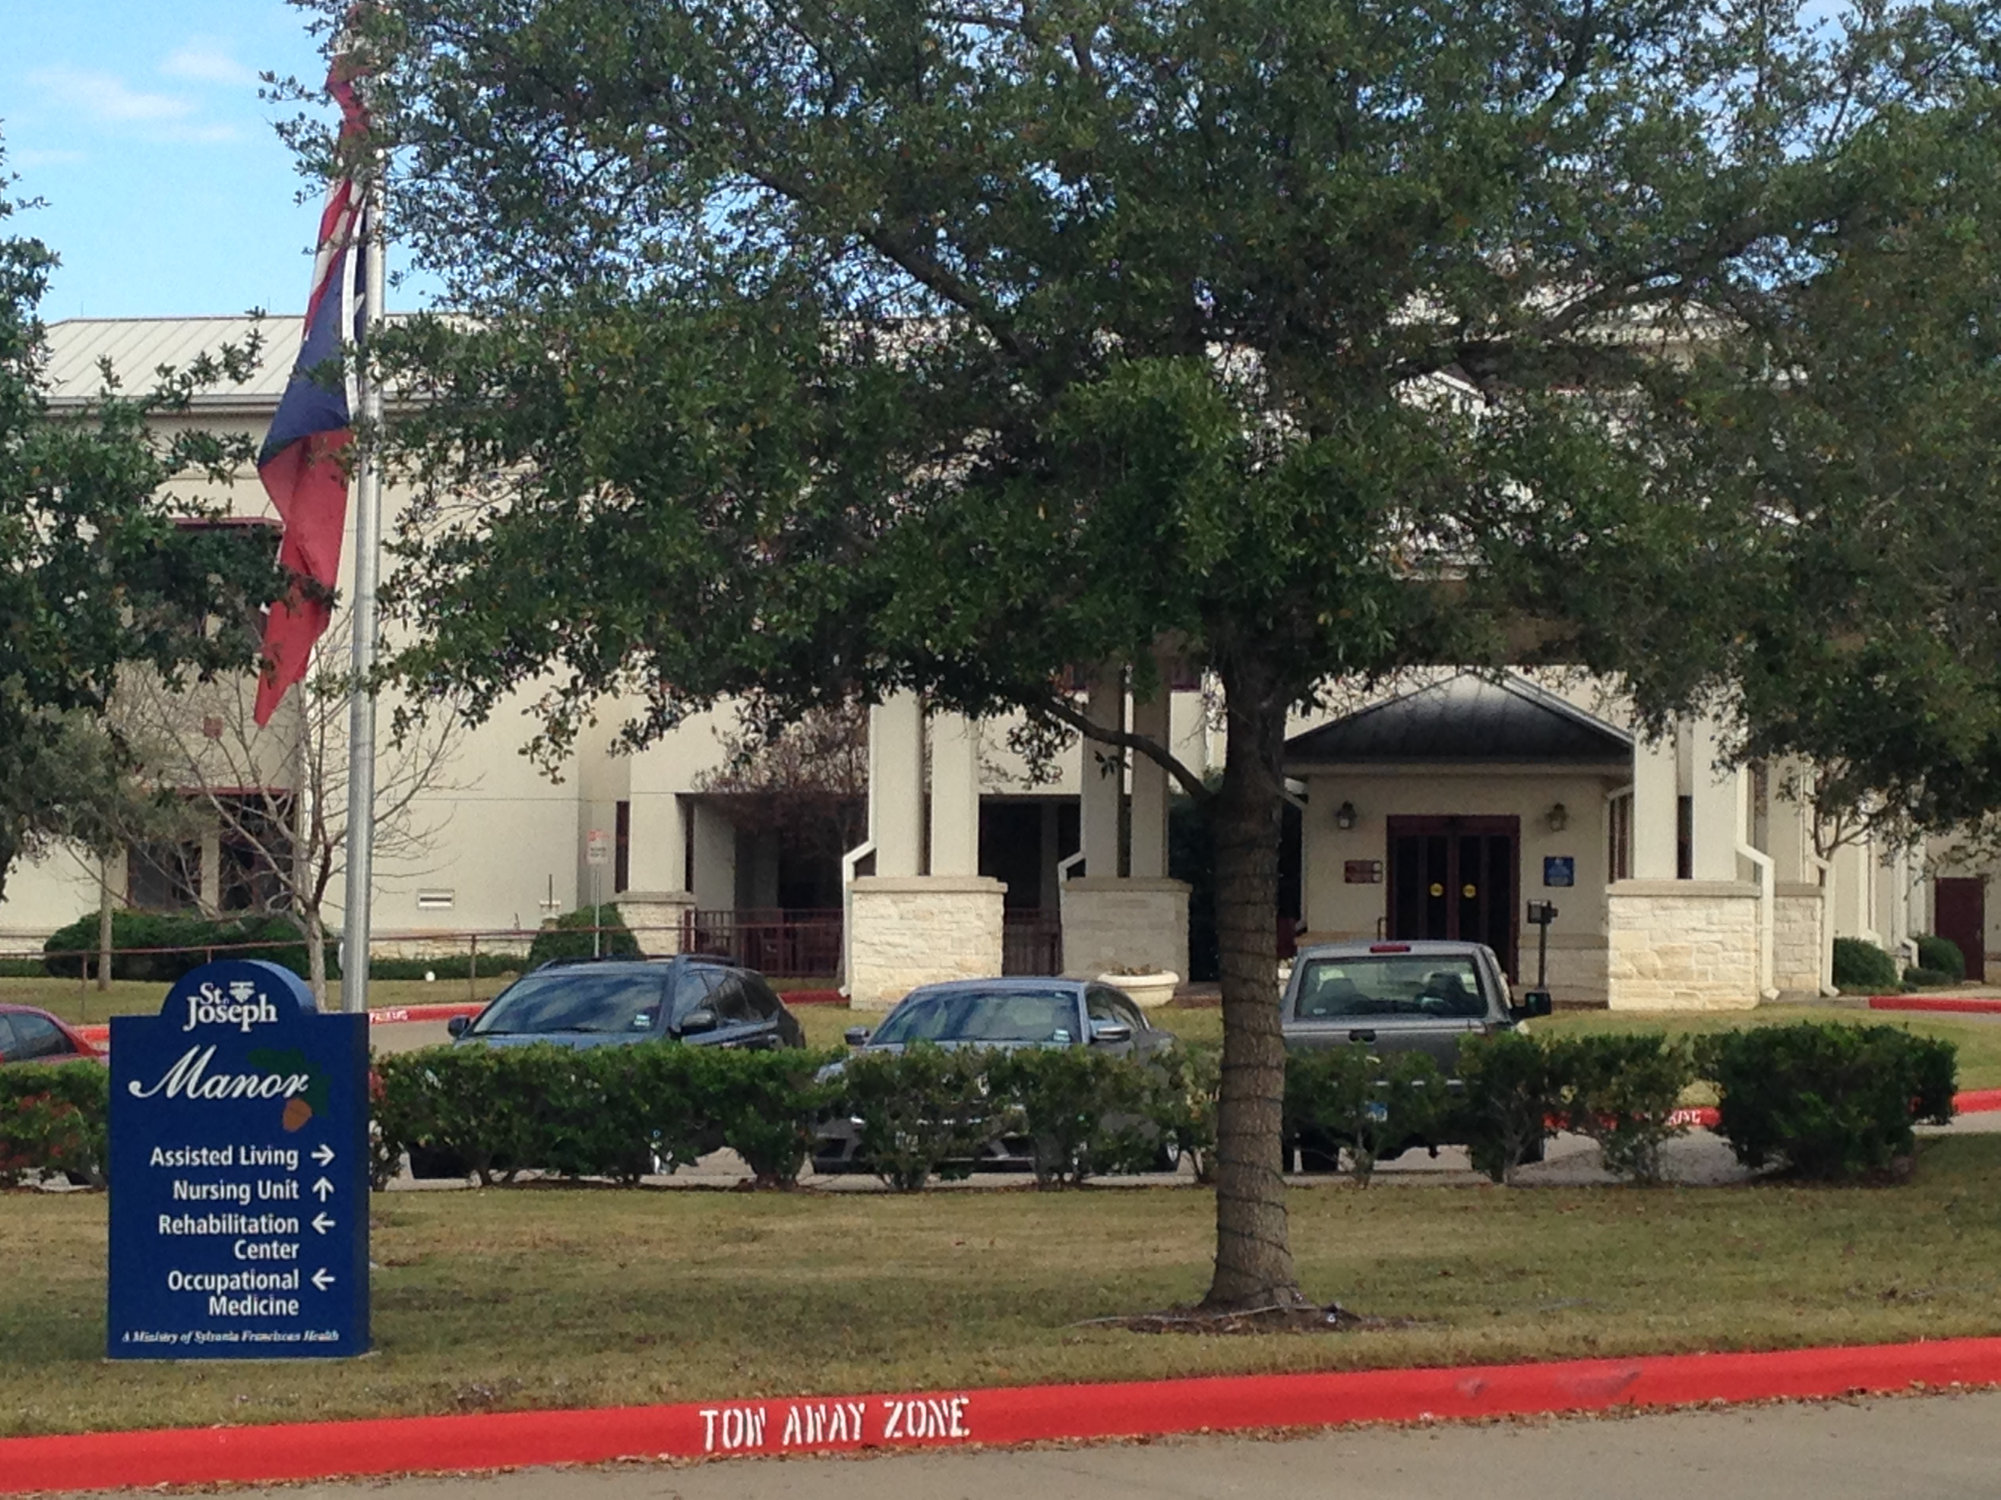Front Entrance (marked Nursing Side)
Department Contact Information:
Report to: Wendy Day
Contact: (512) 417-5600; WDay@st-joseph.org

Sign-in: Volunteer binder in main lobby, granite bar on left hand wall

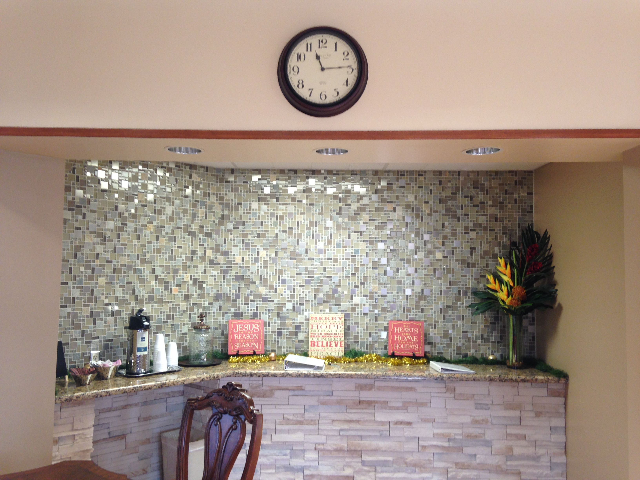Volunteer binder located on granite bar

Department Orientation Checklist: Will be completed during your first schedule shift

Additional Orientation Courses:
- Go to http://www.chistjoseph.org/volunteer
- On the left side of the screen, click on Volunteer Orientation Access
- At the log in, enter
  - name: sjvolunteer
  - Password: vol123
- On left side of screen, click on Senior Enrichment Program:
  - View: Senior Enrichment Program Orientation
  - Complete: Senior Enrichment Program Orientation Acknowledgement
- If you are ill or cannot make your shift, please call the number listed above to report your absence. You do not need to call Volunteer Services.
- Dress Code: Assigned Uniform Top, khaki pants, and rubber soled shoes. No denim, capris, shorts, or sleeveless shirts. No perfume or cologne in patient areas.
- Remember to take your department orientation checklist (included in this packet) on your first day or to scheduled department orientation. Please complete and return to Volunteer Services.
New Volunteers:
- Your identification badge will be delivered to your location for you to pick up on your first day. You are required to wear your badge while on duty. If you forget your badge you will be asked to leave.
How to turn in Paperwork to Volunteer Services:
Interoffice mail to Volunteer Services, drop off in wall basket in Auxiliary office, scan and email to volunteer@st-joseph.org, or fax to 979.776.5330.

Senior Enrichment Assistant

Objective: To provide excellent services to meet resident needs and provide assistance to patient care staff and support unit operations.

Hours: Daily 8:00 am – 8 pm

Qualifications:
- Demonstrates ability to communicate and listen well.
- Ability to take initiative and be flexible assuming differing roles as needed to provide comfort for patients and guests.
- Mature, positive, service-oriented individual.
- Ability to work closely with other members of the team.
- Physical ability to withstand sitting, standing, reaching and lifting.
- Bilingual skills are helpful.

Training:
- Completion of Hospital Orientation.
- Completion of Department Orientation.

Competencies:
- Understand and follow directions.
- Work effectively with others.
- Recognize and respect diverse needs of our senior citizens.
- Work with confidential information and records.
- Age-specific standards

Responsibilities:
- Notify department of any absences; sign in and out when reporting to and leaving volunteer assignment, wear volunteer uniform and issued identification badge; maintain confidentiality at all times and do not discuss any information learned while on-site to anyone outside of the unit, department, or CHI.

- Run an exercise class with our Residents
- Call out trivia
- Call Bingo
- Take Residents to and from activities
- Help with Ice cream socials
- Painting Nails
- Going on Outings with residents to the movies and restaurants
- Doing crafts
- Visiting Residents one on one
- Decorating the facility
- Passing out items such as menus, and monthly calendars
- Reading to and with Residents
- Anything clerical that may be needed
- Organizing
- Help with parties and socials
- Any kind of puzzles and games you can imagine

Department Orientation Checklist
Senior Enrichment Assistant

VOLUNTEER NAME:_____________________________________________

_____Introduction to team members

_____Department tour

_____Review basic department functions

_____Define who they report to when on duty

_____Define who to call when the volunteer will be unable to volunteer for their assigned shift (information does not need to be reported to Vol. Svcs.)

_____Point out location of: Policy and Procedure Manual
Disaster Manual or Plan
MSDS Manual
Safety Manual
Code Cards
Sign in book

_____Point out location of nearest fire alarm and extinguishers

_____Review department evacuation procedure

_____ Review Volunteer Daily Duties:

___________________________ _______________________________ _________
Department Team Member Signature Volunteer Signature Date

Please return this form to Volunteer Services Department by interoffice mail, fax to 979.776.5330, or email to volunteer@st-joseph.org

Volunteer Time Sheet
Please send time sheets at the beginning of each month to Volunteer Services: email volunteer@st-joseph.org.

Assignment: Senior Enrichment/Assisted Living

Date | Name | Time In | Time Out | Total Hours

Please send time sheets at the beginning of each month to Volunteer Services email volunteer@st-joseph.org.

